Mission to Myanmar
Games
Suggestions Only!
These ideas are only suggestions, of course. You may have other games you want to play in place of, or in addition to, these games. Most games I have seen in Myanmar are very simple – soccer, badminton, volleyball, jumping rope. Any of these games will work well in your VBS!
Here are some other suggestions:
Relay Races
Myanmar kids (and some adults too) love relay races. Favorites are:
- Running with a spoon full of rice and trying to empty one bowl and fill up the other bowl with rice before the other team.
- Running with a balloon between the knees. Check out this video of grown women doing a relay race!
https://www.facebook.com/phobe.thaung/videos/413780545484825/
- Running in flip flops. Each team has one pair of flip flops. The first runner runs to the goal and back again in flip flops and then removes the flip flops and hands them to the next runner. The second runner puts on the flip flops, runs to the goal and back again, removes the flip flops and hands them to the next runner. This cycle repeats itself until all runners on both teams have had a turn.
Cooperative Games are on the next page.

Cooperative Games
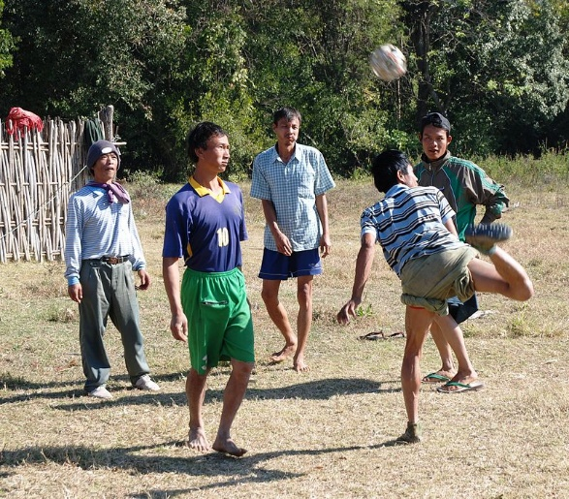
- Children often play chinlon, a hacky-sack-like game in which participants try to keep a woven bamboo ball in the air without using their hands. Rather than a woven bamboo ball (smaller sizes can be found at Walmart and craft stores), it may be easier to play with a medium sized inflatable ball. I’ve played a slower version of this using balloons.

- The water festival is celebrated in April, during the Buddhist new year. One of the things that happens is that people pour water on each other. If you even walk down the street during the water festival, it is likely that a complete stranger will pour water on you! If you are on a train, and your windows are down and you stop at a station, people will throw water through the windows! Although not a game, you can provide a tub (like a kiddie pool) and paper cups and children can throw water on each other. Not such a bad activity for a hot summer day!

