Mission to Myanmar
Crafts
Suggestions Only!
These ideas are only suggestions, of course. You may have some very crafty people in your group who can come up with amazing items for the kids to work on and enjoy. That’s OK! The crafts I have selected are all from Oriental Trading Company. I’ve tried to keep costs down, and fun and creativity up, all the while minimizing the work of the craft leaders. I have also tried to select crafts that will go along with each day’s Bible lesson, as well as teach something about Myanmar.
Setting the Stage
Each day, greet the children with “mingalaba” and have them take off their shoes. Generally, Myanmar kids work on the floor, or at desks that are low to the floor. If this works for you GREAT. If not, that’s OK too. We want everyone to learn, be creative and just have fun!
Mission to Myanmar
Day One
Creation
Supplies Needed:
8X10 photograph of hot air balloons (Like the one on the right)
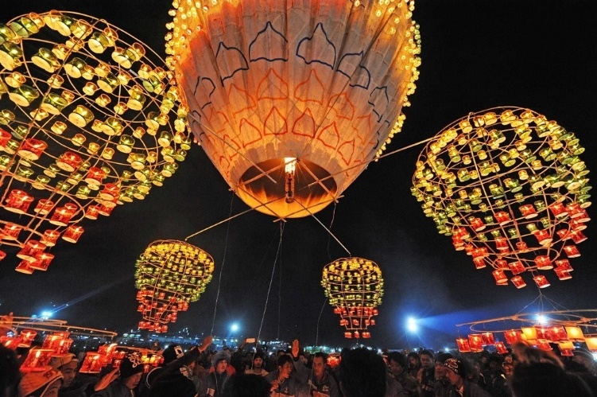
Suncatcher ($9.99 for 12)- Item # IN-13728808. This craft will also require paint, such as
Neon Suncatcher Paint ($16.99 for set of six paints) adequate for all the painters -- Item # IN- 13764082.
Paint brushes ($9.49/150 brushes) Item # IN – 56/2607.
You will need small containers to distribute the paint,
Water to clean brushes,
Paper towels to dry brushes.
Painting suncatchers is not hard, but there are a few tricks! Here’s a link to a YouTube video that could be useful. https://www.youtube.com/watch?v=PLY6qEJBEGs.
Introduce the Craft:
God created the universe and our own Earth! He created all this simply by speaking them into existence.
Today we are going to make some hot air balloons. Air is invisible, yet it is all around us and is one of the things that makes life possible! God created both visible and invisible things! In the city of Taunggyi (Taun –gi) each year there is a hot air balloon festival. It is part of a Buddhist celebration called “Festival of Lights”. The celebration of light is to remind people that they can continually improve their level of knowledge.
But most of them do not know that Jesus is the Light of the World (John 8:12). As we make our own hot air balloon we can remember that Jesus brings light into darkness.

Make the Craft:
Paint the suncatcher. Be sure and compliment everyone on their efforts. Some kids might like to tell you why they chose various colors. If the kids complete the project before the time is us, lead them in a discussion about hot air balloons. Ask: Have you ever seen a hot air balloon? What did it look like? Have you ever ridden in one? Was it fun? Where would you like to go in a hot air balloon? (There are many articles on the internet that explain the science of hot air balloons, if you want to be prepared to go a little deeper!)

Mission to Myanmar
Day Two
Jesus is Born
Review “Setting the Stage” for greetings and room set up.
Supplies Needed:
8X10 photograph of Myanmar Christmas tree
Joy Nativity Christmas Craft ornament ($6.99/12) Item # IN-48/6365,
Glue – Elmer’s Washable School Glue ($13.99/gallon) Item IN-13752798.
Small cups to hold glue,
Q-tips to apply glue.
Introduce the Craft:
Did you know that Christmas is a big holiday in Myanmar? That is surprising, since Myanmar is a Buddhist country! That means that most people have never heard about Jesus. They don’t know that Jesus came to earth from Heaven as a baby and to be our Savior. They just know they enjoy decorating Christmas trees and seeing Christmas lights. But because Myanmar people like Christmas so much, it is the best time of year to tell them about Jesus! They want to know about Jesus and why people around the world celebrate His birth.
Many Christians go caroling, singing Christmas songs at their neighbors’ houses. Churches and Christian schools put on special programs and have special meals. People love to hear about Jesus, and some become Christians during this time.
Make the craft:
Have a completed example to show the children. Assist them as necessary in gluing the pieces together. (NOTE – if you think the pieces are too small for little hands, simply choose another Christmas craft from Oriental Trading or whatever source you wish to use. It should be a craft that celebrates Jesus.) You may want to print “Mission to Myanmar” 2018 on the back.
This craft will remind children that Jesus brings us joy because he left Heaven to come to Earth. It can also remind children that children in Myanmar need to know about Jesus as well so they can truly celebrate Christmas. You can engage the children in conversation by asking them about what they do to celebrate Christmas.

Mission to Myanmar
Day Three

Jesus is Crucified and is Resurrected
Review “Setting the Stage” for greetings and room set up.
Supplies Needed:
Color Your Own Cross Fuzzy Picture from Oriental Trading Company ($4.78/12), Item No. IN-48/1918
Crayola Markers ($5.99/set) IN-13747038.
Introduce the Craft:
Although Christmas is very well celebrated in Myanmar, Easter is not. As Christians, we celebrate that Jesus overcame death – that he was crucified for our sins, and rose from the dead. Buddhists don’t understand this, because Buddha never rose from the dead. Buddhists believe that humans cannot know what happens after death. They don’t understand the need for a Savior to save them from their sins. They think that if they do enough good works that the universe might somehow reward them. Many Buddhists live in fear and will make sacrifices to spirits called “nats” to try to keep bad fortune away from them.
Buddhists need to hear about this good news about Jesus – and so do our families and neighbors. This Easter craft will remind students that Jesus is alive!
You can also add to the meaning of the craft by suggesting that the cross be colored in six colors:
Black representing sin – For all have sinned and fallen short of the glory of God (Romans 3:23)
Red representing the blood of Jesus – While we were yet sinners, Christ died for us (Romans 5:8)
Blue representing baptism – We were buried with him through baptism (Romans 6:4)
White representing being cleansed from sin – Wash me, and I shall be whiter than snow (Psalms 51:7)
Green representing growth in our Christian life – Grow in grace and in the knowledge of our Lord and Savior Jesus Christ (2 Peter 3:16)
Gold representing our home in Heaven – Be faithful unto death and I will give you a crown of life. (Revelations 2:10)
Color the craft – talking about the six colors, asking questions about each color.
Black – What is sin? (It is doing something that is wrong. Children can give examples)
Red – Why is the blood of Jesus important? (It has the power to wash away all our sins)
Blue – What is baptism? (The act of baptism symbolizes we are accepting Christ and our sins are washed away)
White – How are we different in God’s eyes after baptism? (We become sons and daughters of God, our sins are not held against us.)
Green – How do we grow as Christians? (Bible study, prayer, doing good works, going to chu)rch)
Gold – What is Heaven? (A beautiful and happy place where we will be with Jesus forever

